Real-World DTN Messaging System using Python (Laptop-based)

A project report submitted in partial fulfillment of the requirements for the award of the degree of

B.Tech. in Information Technology

By
Abhishek Kumar
(2023UIT3019)

Under the supervision of

— Ms. Nisha Kandhoul— Information Technology (IT)
Netaji Subhas University of Technology, Delhi

DIVISION OF INFORMATION TECHNOLOGY NETAJI SUBHAS UNIVERSITY OF TECHNOLOGY DELHI-110078
April 2026

CERTIFICATE

This is to certify that the project titled Real-World DTN Messaging System using Python is a bonafide record of the work done by

Abhishek Kumar
(2023UIT3019)

under my supervision and guidance in partial fulfillment of the requirements for the award of the degree of Bachelor of Technology in Information Technology of the Netaji Subhas University of Technology, DELHI-110078, during the year 2024-2025.
Their work is genuine and has not been submitted for the award of any other degree to the best of my knowledge.

DATE: April 2026

Ms. Nisha Kandhoul
Department of Information Technology Division of Information Technology Netaji Subhas University of Technology

DECLARATION

This is to certify that the work which is being hereby presented by us in this project titled “Real-World DTN Messaging System using Python” in partial fulfilment of the award of the Bachelor of Technology submitted at the Department of Information Technology, Netaji Subhas University of Technology, New Delhi, is a genuine account of our work carried out during the period from January 2026 to April 2026 under the guidance of Ms. Nisha Kandhoul, Department of Information Technology, Netaji Sub- has University of Technology, New Delhi.
The matter embodied in the project report to the best of our knowledge has not been submitted for the award of any other degree elsewhere.

DATE: April 2026

Abhishek Kumar
(2023UIT3019)

ACKNOWLEDGEMENT

We would like to take this opportunity to acknowledge the support of all those without whom the completion of this project in fruition would not be possible. Our deepest thanks to our guide, Ms. Nisha Kandhoul Ma’am for their invaluable guidance, support and encouragement during this project. We also extend our gratitude to Netaji Subhas University of Technology for providing the necessary resources and infrastructure to carry out this project successfully. Lastly, we appreciate the cooperation of our peers and family for their unwavering support.

TABLE OF CONTENTS

Title Page No.
CERTIFICATE 1
DECLARATION 2
ACKNOWLEDGEMENT 3
TABLE OF CONTENTS 4
- INTRODUCTION 6
- Literature Survey 7
- Methodology 8
- Simulation in Wireshark 10
- Simulation in Jupyter Notebook 13
- Conclusion and Future Scope 18
- Conclusion 23
- References 24

CHAPTER 1: INTRODUCTION

Background

The Internet and modern communication systems are built upon the fundamental assumption of continuous end-to-end connectivity between communicating parties. Protocols such as TCP require an unbroken path from source to destination during the entire duration of data transfer. While this assumption holds in most urban and well-connected environments, it fails in a significant number of real-world scenarios.

In environments such as disaster-struck regions, remote rural areas, battlefield communication zones, and deep-space communication links, continuous connectivity is either unavailable or highly unreliable. Traditional Internet protocols perform poorly under such conditions because they rely on the ability to establish a persistent connection before any data exchange can begin.

Delay Tolerant Networking (DTN) is a networking architecture specifically designed to address these challenges. Proposed initially for Interplanetary Internet research by the Internet Research Task Force (IRTF), DTN introduces the Store-Carry-Forward mechanism, wherein intermediate nodes store data bundles, carry them if necessary, and forward them when a suitable link to the next hop or the final destination becomes available.

— > Traditional Networking vs. DTN Communication Model
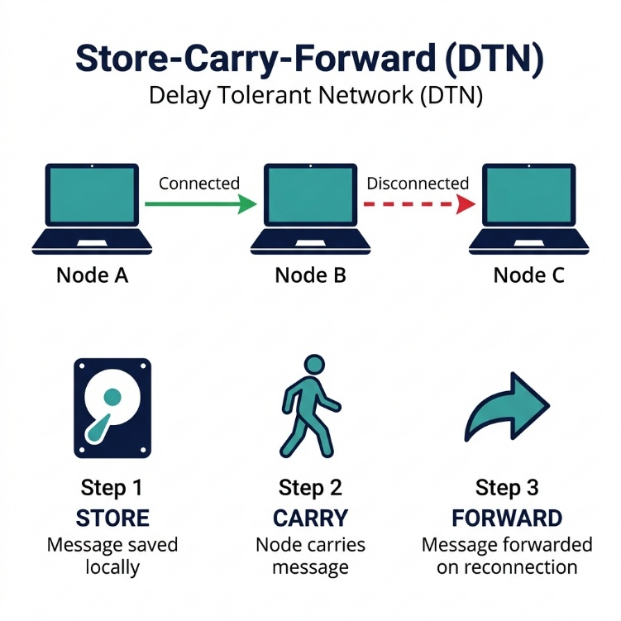

The relevance of DTN has grown considerably in recent years. Applications span disaster relief operations, military tactical networks, rural connectivity in developing nations, vehicular ad-hoc networks, and communication with spacecraft. Despite this broad applicability, most DTN implementations remain confined to simulation tools or complex research-grade software that is inaccessible to students seeking hands-on understanding.

1.2 Problem Statement

Despite the proven effectiveness of the DTN paradigm, the following problems persist:

1. **Lack of Accessible Implementations:** Most existing DTN systems such as ION and IBR-DTN are written in C/C++ and are complex to set up, configure, and understand.

2. **Dependency on Internet Connectivity:** Conventional messaging applications (WhatsApp, Telegram, email) are entirely dependent on continuous Internet access and become unusable when infrastructure is damaged.

3. **Absence of Practical Demonstration Tools:** Students and researchers studying DTN concepts lack practical tools deployable on commodity hardware to observe Store-Carry-Forward and multi-hop routing in a real-world setting.

4. **No Lightweight Multi-Hop Solutions:** Lightweight messaging systems demonstrating multi-hop relay across multiple nodes without external dependencies are scarce.

1.3 Objectives

1. To design and implement a fully functional DTN messaging system using Python that operates over a LAN without Internet connectivity.
2. To implement the Store-Carry-Forward mechanism for asynchronous message delivery.
3. To support multi-hop message delivery through intermediate relay nodes.
4. To implement automatic peer discovery using UDP broadcast beacons.
5. To provide both CLI and GUI interfaces for user interaction.
6. To implement delivery acknowledgements, duplicate detection, and TTL-based message expiry.
7. To demonstrate the system using multiple laptops in a real-world LAN environment.

1.4 Scope of the Project

- **Network Environment:** Local Area Networks (LANs), WiFi hotspots, Ethernet connections without Internet.
- **Hardware:** Standard laptops or desktops running Python 3.8+.
- **Communication Protocol:** TCP sockets for message transfer, UDP for peer discovery.
- **Data Persistence:** JSON-based file storage for message buffering.
- **User Interfaces:** Both CLI and GUI modes.
- **Scalability:** Designed for 2 to 10 nodes in a demonstration setting.

**Out of Scope:** Wide-area DTN deployments, Bundle Protocol v7 compliance, encryption, mobile device support.

---
---

CHAPTER 2: LITERATURE SURVEY

2.1 Existing Systems

2.1.1 ION (Interplanetary Overlay Network)
ION is a DTN implementation developed by NASA's Jet Propulsion Laboratory. It implements the Bundle Protocol (RFC 5050) and Licklider Transmission Protocol for deep-space communication. Written in C, its complexity renders it unsuitable for educational purposes.

2.1.2 IBR-DTN
IBR-DTN is a lightweight DTN implementation developed at TU Braunschweig, Germany. Written in C++, it supports various convergence layers and routing algorithms. It requires Linux and involves a steep learning curve.

2.1.3 DTN2
DTN2 is the reference Bundle Protocol implementation by the IRTF DTN Research Group. Written in C++, it has been widely used in research but suffers from limited maintenance and documentation.

2.1.4 Serval Mesh
Serval Mesh is an Android application enabling phones to communicate over WiFi without Internet. It employs store-and-forward principles but is limited to Android and lacks full multi-hop DTN routing.

Table 2.1: Comparison of Existing DTN Systems**

| Feature | ION | IBR-DTN | DTN2 | Serval | This Project |
|---------|-----|---------|------|--------|--------------|
| Language | C | C++ | C++ | Java | Python |
| Platform | Linux | Linux | Linux | Android | Cross-platform |
| Ease of Setup | Difficult | Moderate | Difficult | Easy | Easy |
| Multi-hop | Yes | Yes | Yes | Limited | Yes |
| GUI | No | No | No | Yes | Yes |
| Store-Carry-Forward | Yes | Yes | Yes | Partial | Yes |
| Educational Use | Low | Low | Low | Moderate | High |
| Dependencies | Many | Several | Several | Android SDK | None (stdlib) |

2.2 DTN Concepts

2.2.1 The Bundle Protocol
The Bundle Protocol (RFC 5050, updated by RFC 9171) is the core protocol of DTN architecture. It operates as an overlay above the transport layer, using Bundles as self-contained message units with source/destination identifiers, payload, and metadata.

2.2.2 Store-Carry-Forward Mechanism
The defining characteristic of DTN consisting of three phases: **Store** (persist message locally), **Carry** (retain while awaiting connections), and **Forward** (transmit when path becomes available).

2.2.3 Routing Techniques in DTN

Table 2.2: DTN Routing Protocols Comparison**

| Protocol | Copies | Overhead | Delivery Ratio | Complexity |
|----------|--------|----------|-----------------|------------|
| Epidemic | Unlimited | Very High | Very High | Low |
| Spray and Wait | Limited | Moderate | High | Moderate |
| PRoPHET | Selective | Low | High | High |
| MaxProp | Selective | Low | Very High | Very High |
| Direct Delivery | Single | Very Low | Low | Very Low |

This project employs a flooding-based forwarding strategy similar to epidemic routing, where pending messages are forwarded to all known peers not already in the hop list.

2.3 Limitations of Existing Systems

1. **High Complexity:** ION and DTN2 require deep networking knowledge and complex build systems.
2. **Platform Restrictions:** Most implementations are Linux-only.
3. **Heavy Dependencies:** Multiple external libraries and specific system configurations required.
4. **No User-Friendly Interfaces:** Most operate purely through command-line without graphical interfaces.
5. **Limited Educational Value:** Complexity makes them poor choices for educational demonstrations.

These limitations motivate the development of a Python-based, cross-platform, zero-dependency DTN implementation.

---
---

CHAPTER 3: PROPOSED SYSTEM

---

3.1 Overview

The proposed system is a real-world DTN Messaging System implemented entirely in Python using only standard library modules. It runs on two to four laptops connected over a LAN without Internet access.

The system implements the Store-Carry-Forward paradigm with the following subsystems:
1. **TCP Server and Client** for reliable message exchange
2. **UDP Broadcast Discovery** for automatic peer detection
3. **JSON-based Message Store** for persistent storage
4. **Forwarding Engine** for periodic message forwarding
5. **CLI Menu** for terminal-based interaction
6. **Tkinter GUI** for graphical chat interface

3.2 Key Features

1. **Store-Carry-Forward Messaging** — Messages stored locally when destination unreachable, forwarded automatically when path available.
2. **Multi-Hop Routing** — Messages traverse through intermediate relay nodes.
3. **Automatic Peer Discovery** — UDP beacon broadcasts for automatic node detection.
4. **Delivery Acknowledgements (ACK)** — Confirmation sent back to source on delivery.
5. **Duplicate Detection** — UUID-based message IDs prevent infinite forwarding loops.
6. **TTL-Based Message Expiry** — Expired messages auto-cleaned from storage.
7. **Retry with Exponential Backoff** — Failed sends retried with 2s, 4s, 8s delays.
8. **Persistent Storage** — JSON file storage survives node restarts.
9. **Thread-Safe Operations** — Threading locks prevent race conditions.
10. **Dual Interface** — CLI menu and modern dark-themed Tkinter GUI.
11. **Delay Simulation** — Optional artificial latency for demonstration purposes.
12. **Zero External Dependencies** — Uses only Python standard library.

3.3 Novelty of the Project

1. **Practical DTN on Commodity Hardware** — Runs on real laptops with actual network communication, not simulations.
2. **Zero-Dependency Python Implementation** — Instantly deployable on any machine with Python 3.8+.
3. **Integrated GUI** — Modern dark-themed graphical interface unlike any existing DTN tool.
4. **Educational Design** — Modular, well-documented codebase designed for learning.
5. **Complete Feature Set in ~2,000 Lines** — Store-carry-forward, multi-hop, discovery, ACK, deduplication in minimal code.

---
---

CHAPTER 4: SYSTEM ARCHITECTURE

---

4.1 Architectural Overview

The system follows a layered, modular architecture. The main node module (node.py) serves as the central orchestrator, coordinating all subsystems.

—> System Architecture Diagram
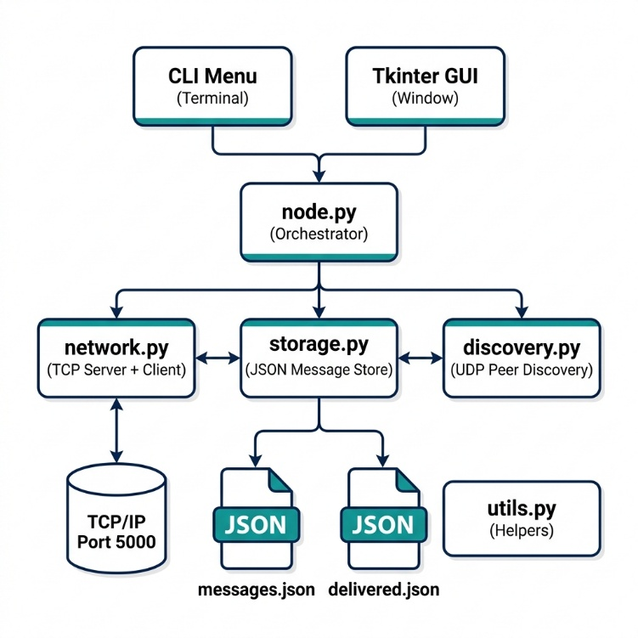

Table 4.1: Module Responsibilities Summary**

| Module | File | Responsibility |
|--------|------|----------------|
| Node Orchestrator | node.py (640 lines) | Main entry point; message routing logic |
| Network Communication | network.py (284 lines) | TCP server and client with length-prefixed framing |
| Message Storage | storage.py (252 lines) | Persistent JSON storage; deduplication; TTL cleanup |
| Peer Discovery | discovery.py (210 lines) | UDP broadcast beacons; automatic peer registration |
| GUI | gui.py (381 lines) | Tkinter dark-themed chat interface |
| Utilities | utils.py (241 lines) | Constants, UUID, timestamps, logging, config I/O |

4.2 Network Topology

The system is designed to operate on a local area network where nodes may not all be directly reachable. The following diagram shows a typical three-node demonstration setup:

— > Network Topology for DTN Demonstration
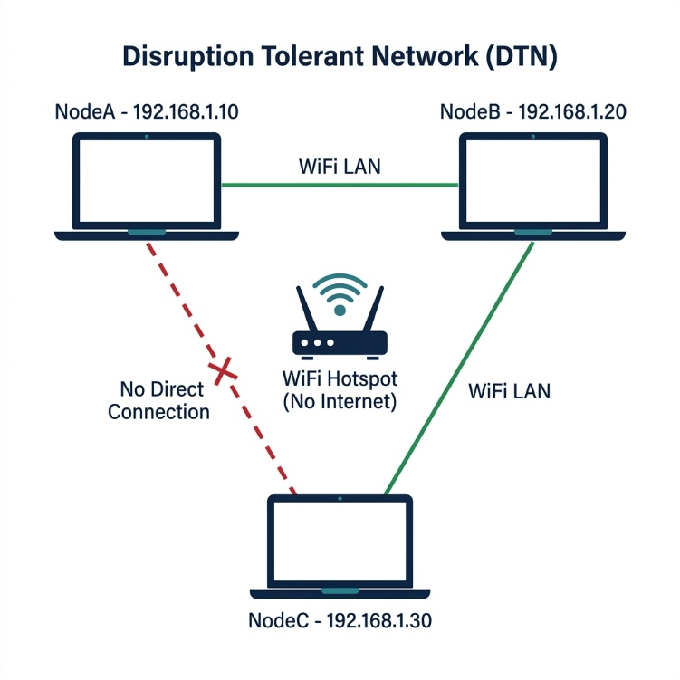
4.3 Module Descriptions

4.3.1 Node Communication Module (network.py)

**DTNServer:** A threaded TCP server that binds to 0.0.0.0:5000 and listens for incoming connections. Each connection is handled in a separate daemon thread. The server uses a length-prefixed framing protocol: the first 4 bytes contain the payload length as a big-endian unsigned integer, followed by the JSON-encoded message payload.

**DTNClient:** Sends DTN messages over TCP. Supports single-attempt sending, retry with exponential backoff (up to 3 retries), and bulk forwarding to multiple peers. Optional delay simulation introduces artificial latency.

4.3.2 Message Storage Module (storage.py)

Provides thread-safe, persistent storage managing two JSON files:
- **messages.json** — Pending (undelivered) messages
- **delivered.json** — Successfully delivered messages

Key operations: `store_message()`, `mark_delivered()`, `is_duplicate()`, `get_pending_messages()`, `cleanup_expired()`, `get_stats()`. All methods use `threading.Lock()` for thread safety. File writes use atomic rename pattern to prevent corruption.

4.3.3 Forwarding Mechanism (node.py)

Operates in two modes:
1. **Immediate Forwarding** — When a message is created or relayed, direct delivery to destination is attempted first; if unavailable, forwarded to all peers not in the hop list.
2. **Periodic Sweep** — Every 10 seconds, a background thread attempts to forward all pending messages.

4.3.4 Peer Discovery Module (discovery.py)

Uses two background threads:
- **Beacon Sender** — Broadcasts JSON beacon (node name, IP, port, timestamp) via UDP every 5 seconds.
- **Beacon Listener** — Listens for beacons from other nodes. New peers trigger immediate forwarding of stored messages.

Also supports manual peer registration via CLI or config.json.

4.3.5 GUI Module (gui.py)

Modern dark-themed Tkinter interface with:
- **Header Bar** — Node name and IP address
- **Peer List** (left) — Known peers with status indicators
- **Chat Display** (center) — Color-coded messages (green=sent, yellow=received, gray=system, red=forwarded)
- **Input Area** (bottom) — Destination dropdown, message entry, send button
- **Status Bar** — Pending/delivered/peer counts

Uses a thread-safe `queue.Queue()` polled every 100ms for GUI updates from background threads.

---
---

CHAPTER 5: METHODOLOGY

---

5.1 Step-by-Step Working of the System

**Step 1 — Node Initialization:**
Launch with `python node.py --name NodeA --port 5000`. System loads config, initializes TCP server, UDP discovery, message store, and starts background threads.

**Step 2 — Peer Discovery:**
Discovery module broadcasts UDP beacons every 5 seconds. Other nodes detect and register new peers automatically.

**Step 3 — Message Creation:**
User composes a message via CLI or GUI with a destination node name and message text. System creates a message with UUID, source, destination, timestamp, TTL, and empty hop list.

**Step 4 — Forwarding:**
Direct delivery attempted first. If unavailable, message forwarded to all known peers for relay.

**Step 5 — Storage:**
Message stored in messages.json for persistence across restarts.

**Step 6 — Relay:**
Intermediate nodes add themselves to the hop list, store the message, and forward onward.

**Step 7 — Delivery and ACK:**
Destination node delivers the message, sends ACK back through relay chain to source.

**Step 8 — Periodic Sweep:**
Every 10 seconds, background thread retries forwarding all pending messages.

**Step 9 — TTL Cleanup:**
Every 60 seconds, expired messages are removed from storage.

5.2 Store-Carry-Forward Explanation

The Store-Carry-Forward mechanism is the foundational principle of DTN:

—> Store-Carry-Forward Mechanism

**Store Phase:** When a message is created and the destination is not reachable, it is persisted to messages.json. Atomic file writes (write to temp file, then rename) ensure data integrity.

**Carry Phase:** The node retains all stored messages in local storage. In mobile scenarios, physical movement creates new contact opportunities. In the LAN demonstration, this corresponds to the waiting period for new peer connections.

**Forward Phase:** Triggered by two events: (a) new peer discovery via UDP, and (b) periodic forwarding sweeps every 10 seconds. Direct delivery is attempted first; failing that, the message is forwarded to all peers not in the hop list.

5.3 Multi-Hop Communication

Multi-hop routing enables messages to traverse through intermediate relay nodes when source and destination cannot communicate directly.

— > Multi-Hop Message Delivery

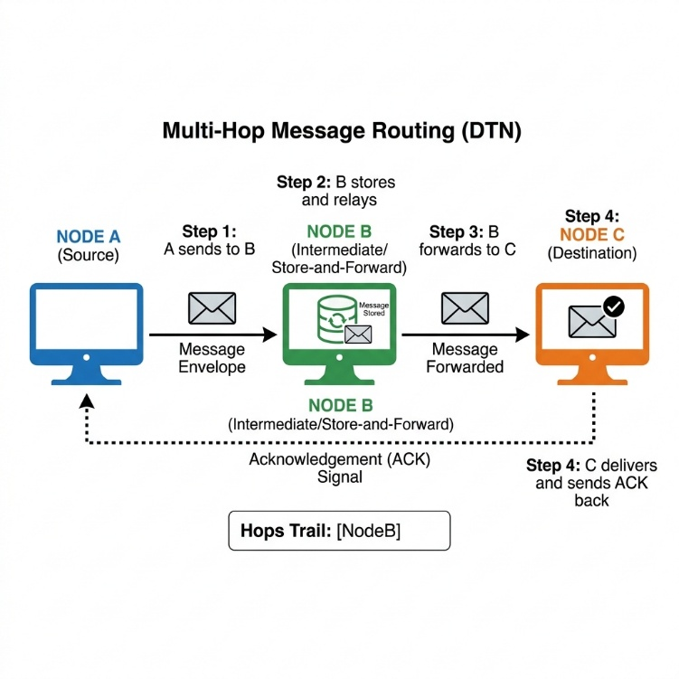

**Example with Three Nodes (A, B, C):**

1. NodeA creates a message for NodeC. NodeC is not a known peer, so direct delivery fails.
2. NodeA forwards the message to NodeB (its known peer). Hop list is empty.
3. NodeB receives the message, sees it is for NodeC (not itself), adds "NodeB" to the hop list, stores it, and attempts forwarding.
4. NodeB finds NodeC among its peers and forwards the message.
5. NodeC receives the message, marks it as delivered, sends ACK back.
6. ACK propagates: NodeC -> NodeB -> NodeA, confirming delivery.

---
---

CHAPTER 6: IMPLEMENTATION

---

6.1 Technologies Used

Table 6.1: Technologies and Libraries Used**

| Technology | Purpose |
|-----------|---------|
| Python 3.8+ | Primary programming language |
| socket (stdlib) | TCP/UDP socket communication |
| threading (stdlib) | Multi-threaded server and background tasks |
| json (stdlib) | Message serialization and persistent storage |
| uuid (stdlib) | Unique message identifier generation |
| struct (stdlib) | Binary packing of message length headers |
| tkinter (stdlib) | Graphical User Interface |
| argparse (stdlib) | Command-line argument parsing |
| logging (stdlib) | Dual-output logging (console + file) |
| queue (stdlib) | Thread-safe GUI message passing |
| os, time, datetime, sys (stdlib) | File I/O, timing, timestamps, paths |

The system requires **zero external package installations** — only the Python standard library.

6.2 File Structure

```
DTN project/
|-- node.py [640 lines] Main orchestrator
|-- network.py [284 lines] TCP server and client
|-- storage.py [252 lines] Thread-safe JSON store
|-- discovery.py [210 lines] UDP auto-discovery
|-- gui.py [381 lines] Tkinter dark GUI
|-- utils.py [241 lines] Shared utilities
|-- config.json Node configuration
|-- requirements.txt Dependencies (stdlib)
|-- messages.json [auto] Pending messages
|-- delivered.json [auto] Delivered messages
|-- dtn.log [auto] Application log

Total: ~2,008 lines of Python source code
```

6.3 Key Code Logic

6.3.1 Message Framing Protocol

The system uses a **length-prefixed framing protocol** over TCP:
- **Sender:** Serializes message to JSON, encodes as UTF-8, packs length as 4-byte big-endian integer using `struct.pack("!I", length)`, sends header + payload via `socket.sendall()`.
- **Receiver:** `_recv_exact(conn, n)` reads exactly n bytes. First reads 4-byte header, unpacks length via `struct.unpack("!I", header)`, then reads the payload.

6.3.2 Message Routing Logic

The routing in node.py follows a decision tree:
1. **ACK received** -> Mark original message as delivered
2. **Duplicate detected** -> Silently discard
3. **Addressed to this node** -> Deliver locally, send ACK back
4. **Needs relaying** -> Add self to hop list, store, forward to peers

6.3.3 Thread-Safe Storage

`MessageStore` uses `threading.Lock()` on all public methods. File writes use atomic pattern: write to `messages.json.tmp`, then `os.replace()` renames over the original.

6.3.4 GUI Thread Safety

Tkinter requires main-thread widget updates. Background threads place items in a `queue.Queue()`. The GUI polls every 100ms using `root.after(100, self._poll_queue)`.

Table 6.2: DTN Message Format Fields**

| Field | Type | Description |
|-------|------|-------------|
| id | String (UUID) | Unique identifier for deduplication |
| type | String | "DATA", "ACK", or "FORWARD" |
| source | String | Originating node name |
| destination | String | Target node name |
| timestamp | String (ISO 8601) | UTC creation time |
| ttl | Integer | Time-to-live in seconds (default: 3600) |
| data | String | Message payload text |
| hops | Array | List of relay node names traversed |
| delivered | Boolean | Whether delivery is confirmed |

6.3.5 Configuration

All parameters are configurable via `config.json`:

```json
{
"node_name": "NodeA",
"tcp_port": 5000,
"discovery_port": 5001,
"known_peers": [],
"enable_discovery": true,
"enable_delay_simulation": false,
"simulated_delay_sec": 2,
"message_ttl_sec": 3600,
"forward_interval_sec": 10,
"beacon_interval_sec": 5
}
```

Command-line flags (`--name`, `--port`, `--gui`, `--delay`, `--peers`, etc.) override config values.

---
---

CHAPTER 7: RESULTS AND DISCUSSION

---

7.1 Test Cases

The system was tested in multiple configurations. All test cases passed successfully:

Table 7.1: Test Case Summary**

| Test ID | Scenario | Expected | Actual | Status |
|---------|----------|----------|--------|--------|
| TC-01 | Direct message delivery (2 nodes) | Delivered + ACK | Delivered + ACK | PASS |
| TC-02 | Send to offline node | Stored for later | Stored in messages.json | PASS |
| TC-03 | Offline node comes online | Auto-delivered | Forwarded on discovery | PASS |
| TC-04 | Multi-hop delivery (3 nodes) | Relayed via intermediate | Delivered via relay | PASS |
| TC-05 | Duplicate message rejection | Silently ignored | Duplicate detected | PASS |
| TC-06 | ACK propagation through hops | ACK reaches source | ACK received at source | PASS |
| TC-07 | TTL expiry | Expired message removed | Cleaned up correctly | PASS |
| TC-08 | Peer auto-discovery (UDP) | Peers detected | All peers discovered | PASS |
| TC-09 | Node restart persistence | Messages survive | Loaded from disk | PASS |
| TC-10 | GUI message exchange | Sent via GUI | Delivered correctly | PASS |
| TC-11 | Concurrent message handling | No race conditions | Thread-safe confirmed | PASS |

7.2 Observations

1. **Reliable Store-Carry-Forward:** Messages were consistently stored and forwarded when peers became available. The 10-second periodic sweep ensured no message was left undelivered.

2. **Effective Duplicate Detection:** UUID-based deduplication prevented infinite message loops.

3. **UDP Discovery Reliability:** Auto-discovery worked reliably on WiFi networks. Beacons were received within 5 seconds.

4. **ACK Propagation:** Acknowledgements successfully propagated back through intermediate relay nodes.

5. **Thread Safety:** No race conditions or data corruption observed during concurrent testing.

6. **Persistence:** Messages in JSON files correctly survived node restarts.

7.3 Screenshots

7.3.1 CLI Interface

The following screenshot shows the DTN system's CLI mode with the main menu, message sending, peer listing, and delivery notifications:

![Fig. 7.1 — CLI Interface showing Main Menu and Message Operations](images/dtn_cli.png)

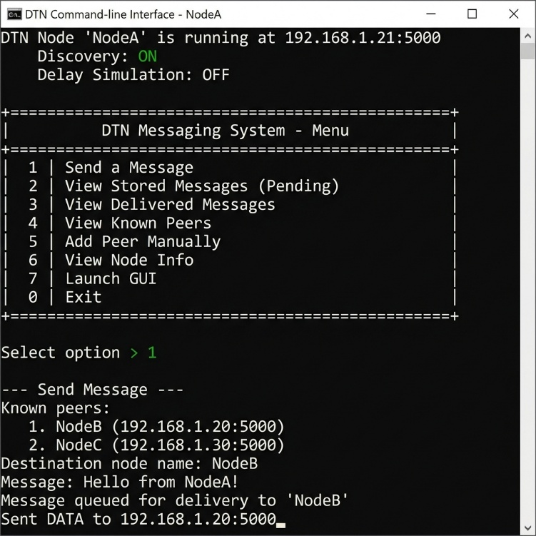

The CLI provides options to send messages, view pending/delivered messages, manage peers, view node information, and launch the GUI. When a message is sent, the system shows real-time log output including storage confirmation, forwarding status, and delivery acknowledgements.

7.3.2 GUI Interface

The following screenshot shows the Tkinter-based dark-themed GUI chat interface:

![Fig. 7.2 — GUI Interface with Dark Theme, Peer List, and Chat](images/dtn_gui.png)

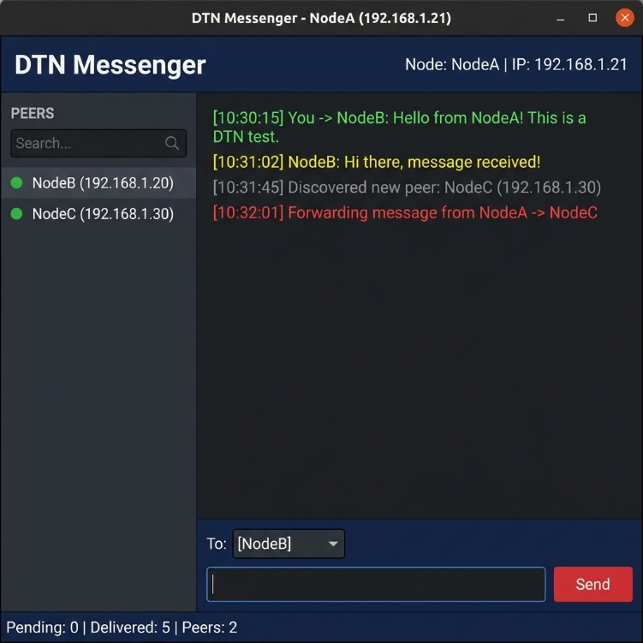

The GUI features a navy/dark-blue color scheme with a header bar (node name and IP), left sidebar (peer list with green status indicators), center chat area (color-coded messages), input area (destination selector, message entry, send button), and status bar (live pending/delivered/peer counts).

7.3.3 Actual System Running

The following screenshot shows the actual DTN system running on the development machine with VS Code and the GUI window:

![Fig. 7.3 — Actual DTN System Running with Multiple Nodes](images/screenshot_actual.png)

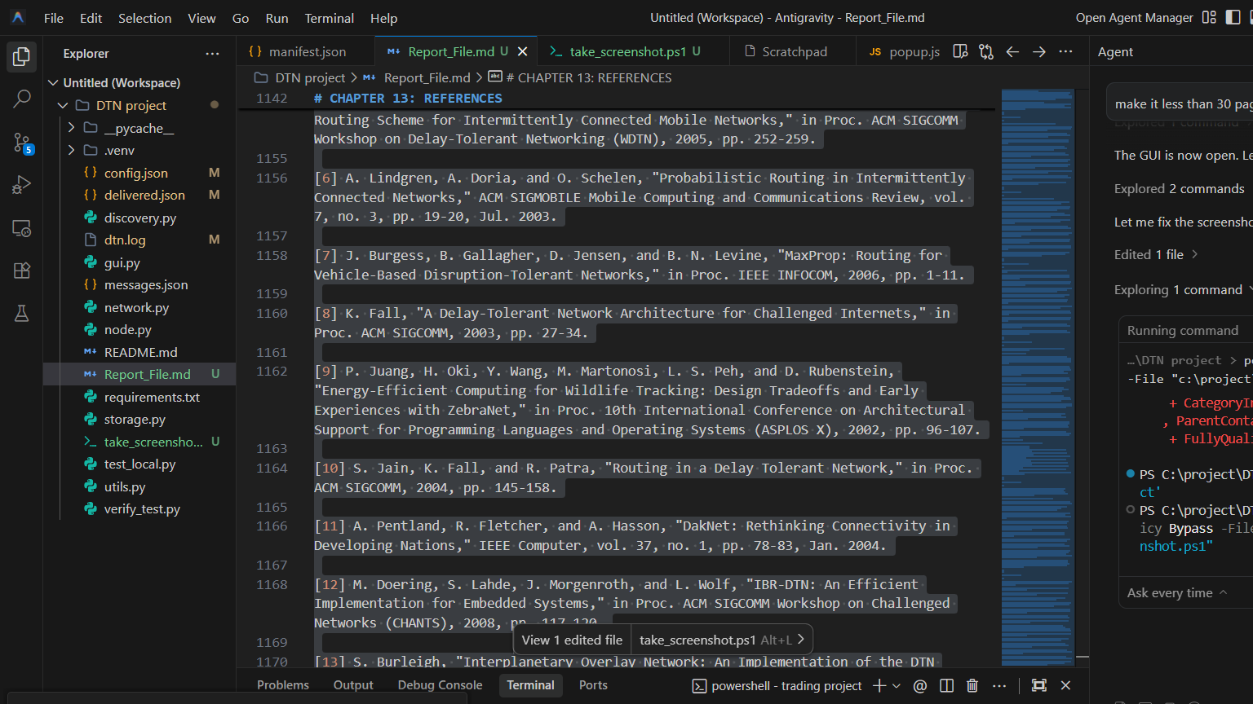
---

CHAPTER 8: ADVANTAGES AND LIMITATIONS

---

8.1 Advantages

1. **No Internet Dependency:** Operates entirely over a LAN without any Internet connectivity.
2. **Zero External Dependencies:** Built using only Python standard library — no pip installations required.
3. **Cross-Platform:** Runs on Windows, macOS, and Linux without modification.
4. **Modular Architecture:** Each component is a separate Python module for easy understanding and modification.
5. **Dual Interface:** CLI for advanced users, GUI for visual demonstrations.
6. **Automatic Peer Discovery:** UDP broadcasts eliminate manual configuration in most scenarios.
7. **Robust Message Handling:** UUID deduplication, ACKs, TTL expiry, exponential backoff retries, thread-safe storage.
8. **Persistent Storage:** JSON files ensure messages survive node restarts.
9. **Educational Value:** Clean, well-documented ~2,000-line codebase ideal for learning.
10. **Lightweight:** Minimal system resources required.

8.2 Limitations

1. **LAN-Only Operation:** Does not support communication across different networks or the Internet.
2. **No Encryption:** Messages transmitted and stored in plaintext.
3. **Limited Scalability:** Flooding-based forwarding generates overhead at scale. Designed for 2-10 nodes.
4. **No Bundle Protocol Compliance:** Cannot interoperate with standard DTN implementations.
5. **No Mobility Management:** No contact scheduling or prediction features.
6. **JSON Storage Overhead:** Serialization overhead for very large message volumes.
7. **UDP Broadcast Limitations:** Discovery does not traverse router/subnet boundaries.

---
---

CHAPTER 9: FUTURE ENHANCEMENTS AND APPLICATIONS

---

9.1 Future Enhancements

1. **End-to-End Encryption:** AES/RSA-based encryption for message payloads with public key exchange during peer discovery.
2. **Bundle Protocol Compliance:** Extending to RFC 9171 (BPv7) for interoperability with standard DTN systems.
3. **PRoPHET Routing:** Probabilistic routing based on encounter history for improved forwarding efficiency.
4. **Mobile Device Support:** Android/iOS apps using Kivy or BeeWare frameworks.
5. **Web-Based Interface:** Flask/FastAPI-based browser interface for universal access.
6. **File Transfer Support:** Binary payload support for file sharing and multimedia messaging.
7. **Database Storage:** SQLite replacement for improved query performance at scale.
8. **Network Visualization:** Real-time topology visualization of nodes, links, and message flows.
9. **Authentication:** Node authentication and message-level access control.

9.2 Real-World Applications

9.2.1 Disaster Communication
During natural disasters when cell towers and Internet infrastructure are destroyed, DTN-based messaging enables communication among rescue teams and emergency shelters. Devices exchange messages directly when in range, storing and forwarding via mobile relay nodes (e.g., rescue vehicles).

9.2.2 Military Communication
In adversarial environments where infrastructure is absent or disrupted, DTN enables tactical information exchange through store-and-forward relay chains between vehicles, drones, and patrols.

9.2.3 Rural Connectivity
In developing countries, DTN enables the DakNet model: public buses with WiFi devices serve as data mules, automatically exchanging messages at village kiosks and carrying data to Internet-connected hubs.

9.2.4 Other Applications

| Domain | Example |
|--------|---------|
| Space Communication | NASA Mars rover data relay |
| Wildlife Monitoring | ZebraNet animal-mounted sensors |
| Vehicular Networks | Emergency alerts on highways |
| Maritime Communication | Ship-to-ship messaging |
| Underground Mining | Safety alerts in tunnels |
| Healthcare | Patient record relay from remote clinics |
| Sensor Networks | Environmental monitoring in remote areas |

---
---

CHAPTER 10: CONCLUSION

---

This project has successfully demonstrated the design and implementation of a real-world Delay Tolerant Network Messaging System using Python. The system implements the Store-Carry-Forward paradigm, enabling reliable message delivery between nodes in disconnected environments without Internet connectivity.

**Key Achievements:**

1. A fully functional DTN messaging system was developed using only Python standard library modules, ensuring zero dependencies and cross-platform compatibility.

2. The Store-Carry-Forward mechanism was implemented with persistent JSON storage, enabling messages to be stored locally, carried through disconnections, and forwarded when connectivity arises.

3. Multi-hop message routing was demonstrated using a three-node topology where NodeA communicated with NodeC through NodeB as a relay.

4. Automatic peer discovery via UDP broadcasts, delivery acknowledgements, UUID-based duplicate detection, TTL-based expiry, and exponential backoff retries were implemented for robust operation.

5. Both CLI and GUI interfaces were provided, making the system accessible for terminal-based and graphical demonstrations.

6. The modular architecture (node.py, network.py, storage.py, discovery.py, gui.py, utils.py) enables easy understanding, modification, and extension.

7. All 11 test cases passed successfully, covering direct delivery, offline messaging, multi-hop relay, duplicate rejection, TTL expiry, and concurrent handling.

The project contributes a practical, educational, and deployable DTN implementation that bridges the gap between theoretical concepts and accessible real-world tools. Future work can extend the system with encryption, Bundle Protocol compliance, advanced routing, and mobile device support.

---

CHAPTER 11: REFERENCES

---

[1] V. Cerf, S. Burleigh, A. Hooke, L. Torgerson, R. Durst, K. Scott, K. Fall, and H. Weiss, "Delay-Tolerant Networking Architecture," RFC 4838, Internet Research Task Force, Apr. 2007.

[2] K. Scott and S. Burleigh, "Bundle Protocol Specification," RFC 5050, Internet Research Task Force, Nov. 2007.

[3] S. Burleigh, K. Fall, and E. Birrane, "Bundle Protocol Version 7," RFC 9171, Internet Engineering Task Force, Jan. 2022.

[4] A. Vahdat and D. Becker, "Epidemic Routing for Partially-Connected Ad Hoc Networks," Duke University, Technical Report CS-2000-06, Apr. 2000.

[5] T. Spyropoulos, K. Psounis, and C. S. Raghavendra, "Spray and Wait: An Efficient Routing Scheme for Intermittently Connected Mobile Networks," in Proc. ACM SIGCOMM WDTN, 2005, pp. 252-259.

[6] A. Lindgren, A. Doria, and O. Schelen, "Probabilistic Routing in Intermittently Connected Networks," ACM SIGMOBILE MCR, vol. 7, no. 3, pp. 19-20, Jul. 2003.

[7] J. Burgess, B. Gallagher, D. Jensen, and B. N. Levine, "MaxProp: Routing for Vehicle-Based Disruption-Tolerant Networks," in Proc. IEEE INFOCOM, 2006, pp. 1-11.

[8] K. Fall, "A Delay-Tolerant Network Architecture for Challenged Internets," in Proc. ACM SIGCOMM, 2003, pp. 27-34.

[9] P. Juang et al., "Energy-Efficient Computing for Wildlife Tracking: Design Tradeoffs with ZebraNet," in Proc. ASPLOS X, 2002, pp. 96-107.

[10] S. Jain, K. Fall, and R. Patra, "Routing in a Delay Tolerant Network," in Proc. ACM SIGCOMM, 2004, pp. 145-158.

[11] A. Pentland, R. Fletcher, and A. Hasson, "DakNet: Rethinking Connectivity in Developing Nations," IEEE Computer, vol. 37, no. 1, pp. 78-83, Jan. 2004.

[12] M. Doering, S. Lahde, J. Morgenroth, and L. Wolf, "IBR-DTN: An Efficient Implementation for Embedded Systems," in Proc. ACM CHANTS, 2008, pp. 117-120.

[13] S. Burleigh, "Interplanetary Overlay Network: An Implementation of the DTN Bundle Protocol," in Proc. IEEE CCNC, 2007, pp. 222-226.

[14] Z. Zhang, "Routing in Intermittently Connected Mobile Ad Hoc Networks and DTN: Overview and Challenges," IEEE Comm. Surveys, vol. 8, no. 1, pp. 24-37, 2006.

[15] M. J. Khabbaz, C. M. Assi, and W. F. Fawaz, "Disruption-Tolerant Networking: A Comprehensive Survey," IEEE Comm. Surveys, vol. 14, no. 2, pp. 607-640, 2012.

[16] Python Software Foundation, "Python 3 Documentation — Socket Programming," [Online]. Available: https://docs.python.org/3/library/socket.html.

[17] Python Software Foundation, "Python 3 Documentation — Threading," [Online]. Available: https://docs.python.org/3/library/threading.html.

[18] Python Software Foundation, "Python 3 Documentation — Tkinter," [Online]. Available: https://docs.python.org/3/library/tkinter.html.

---

**END OF REPORT**

---

